 **Anti-Procrastination Browser Extension   
User Manual (V3)**

**Contact Details:**

-Please get in touch if you have problems to report.

-Please remember to complete the included questionnaire after the trial period. Remember, all questionnaires results will be processed with your anonymity protected, please answer all questions as truthfully as possible and do not leave any identifying information on the questionnaires.

-Email Address: tristanliu@hotmail.co.uk

-Thank you for agreeing to take part in my study, your participation and feedback is greatly appreciated.

**Download:**

In order to download the software, open the email and click on the arrow associated with the attached project file and select “Download”.

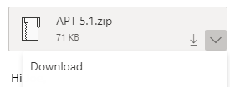

When the file has finished downloading, select it from the downloads bar on the bottom of your screen and click “show in folder” and move it to another location if desired. It is recommended to save this .zip file somewhere you can easily find it, such as “Desktop”.

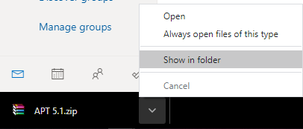

Now, find the .zip file in the location where you have saved it. Right click on the file and select “Extract Here”.

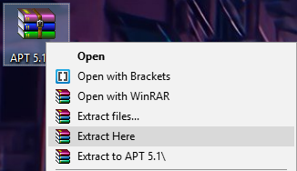

The file should now be unzipped as shown.

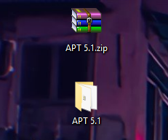

**Installation:**

In order to install the browser extension into Google Chrome, open a Chrome browser and navigate to your extensions manager by typing chrome://extensions in your URL.



On this page, toggle the Developer mode option to on. This setting can be found in the top-right of the page. When toggled on, the switch should resemble the picture below.



Next, select Load unpacked from the top right of the page and locate the unpacked project file in the file explorer popup window.

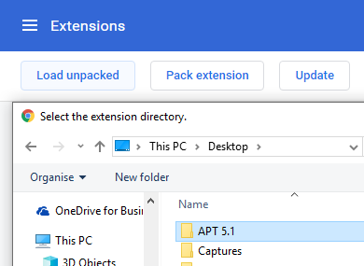

Now, once you have the correct folder highlighted, press Select Folder.

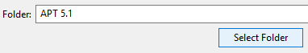

Back on the extensions manager Chrome page, make sure the Anti-Procrastination Trainer can be seen, and that it is toggled on, as in the image below.

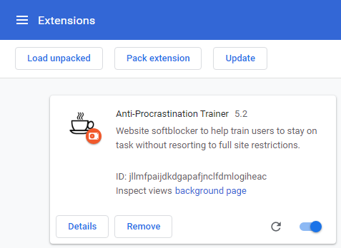

**Functionality/Settings Calibration:**

In your Chrome Browser, you should see the icon for the extension in the top right.

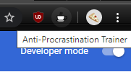

Click on the icon to open the popup settings menu.

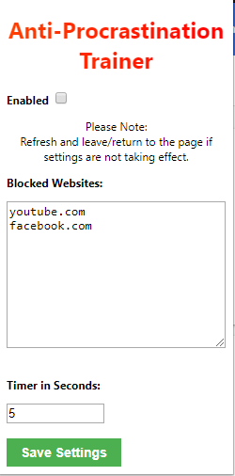**Enabled:** This checkbox determines whether the extension is active or not. In this screenshot, the extension is currently disabled.

**Blocked Websites:** This is a list of websites that the extension considers to be procrastination facilitators. When you are on a website included on this list, the timer will begin to count down. Please only use base-level URLs like the ones shown in the picture to gain the most benefit from the extension.

**Timer in Seconds:** This is the amount of time (in seconds) the timer lasts before the popup appears.

**Save Settings:** This is the button used to save any changes you make in this popup. Settings are saved locally with Chrome, so your settings should persist through uses.

When you navigate to one of the websites on the blocked list, the following popup will appear. Selecting OK will begin the countdown, whereas selecting Cancel will not.

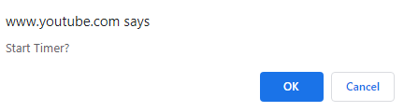

When the popup appears, it will state the amount of time you have spent on the page, and the specific URL of that page. Selecting OK will give you the option to reset the timer, whereas selecting Cancel will pause the functionality until you navigate to another blocked page.

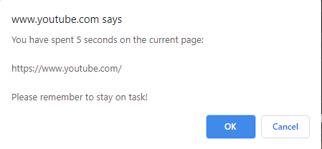

**Problem Troubleshooting:**

If you encounter any problems during the trial phase, you may want to switch tabs to see if the software continues working. Failing that, it may be useful to reinstall the extension. If this still does not fix your problem, please contact me using the details provided above.

**Software Removal:**

To remove the software, navigate back to your Google Chrome extension manager page and click on Remove.

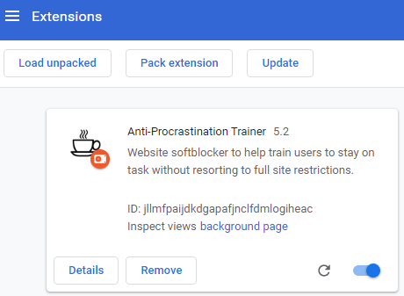

You may also want to disable developer mode and delete both the zipped and unzipped project files you have downloaded.